**COMP464 INTERNET PROGRAMMING**

**Project**

**Spring 2024-25**

**DUE(20/5/2025 23:55PM)**

In this project you are expected to implement the given GUI and its functionality as it is described below. The GUI is for registering to academic events. Please pay attention to the details of the project in your implementation. The initial GUI is presented in figure 1, Figure includes a form and the table. Note that you are required to use only html and javascript for this GUI and its activity. Do not use any Php code.

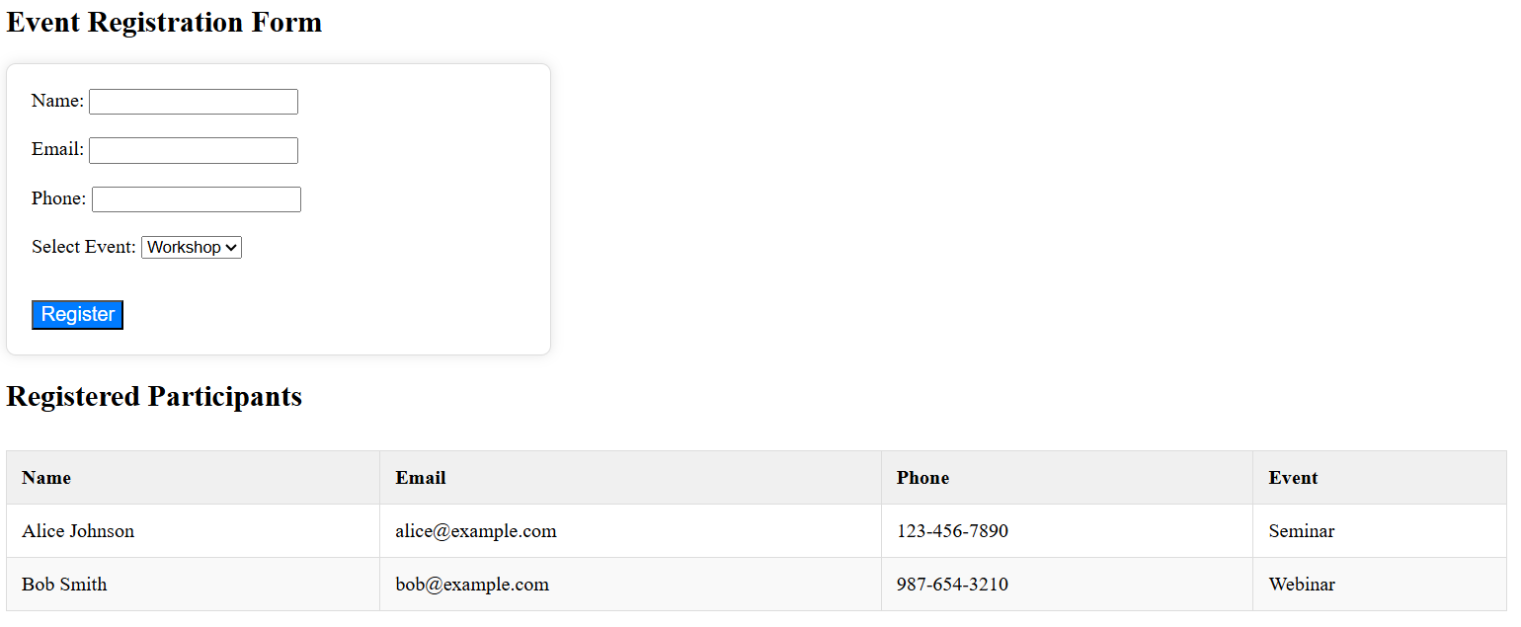

In the program despite writing .js, .css and .html files separate will be a better practice. Please have all of them under a single .html file so that when I get the .html file I will able to run the program without a need of dealing with multiple files.

In the program the details are important. Despite in reality the data in table is usually retrieved from DBMS, since accessing to DBMS require a server side programing in this project it is not used. Despite html and javascript is used as a client side program therefore the data is not retrieved from an external file.

For the initial data in the table you are required to store this data in a string which has a json format and then asked to be retrieved by the AJAX code. Note that that string is stored in javascript code too. Otherwise bringing the .json file would require you to run the code in server side. To clear it up. You are required to write an AJAX code to retrieve the data stored in json format and also the data entered by the form. **Please do not use** fetch method or jquery for the AJAX part of your program.

The data entered in the form should be validated, besides the data should not be empty, it should have the format such as Name must only contain letters and spaces (you are welcome to use jquery to do this). Phone must be in the format 123-456-7890. So once the user clicks register button if there is a problem, pop up should come up to tell your that there is a problem and the system should prevent the data to be added into the table figure 2 & 3. If the format is ok, again by using AJAX you should add the data into the given table Figure 4. Note that you can add members to the form consequently in this case each added data should be updated in the table.

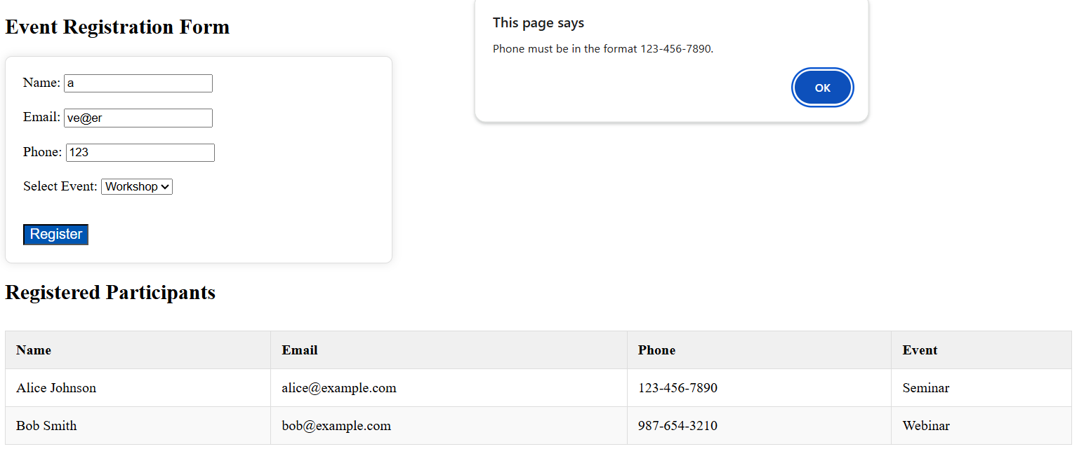

Figure 2

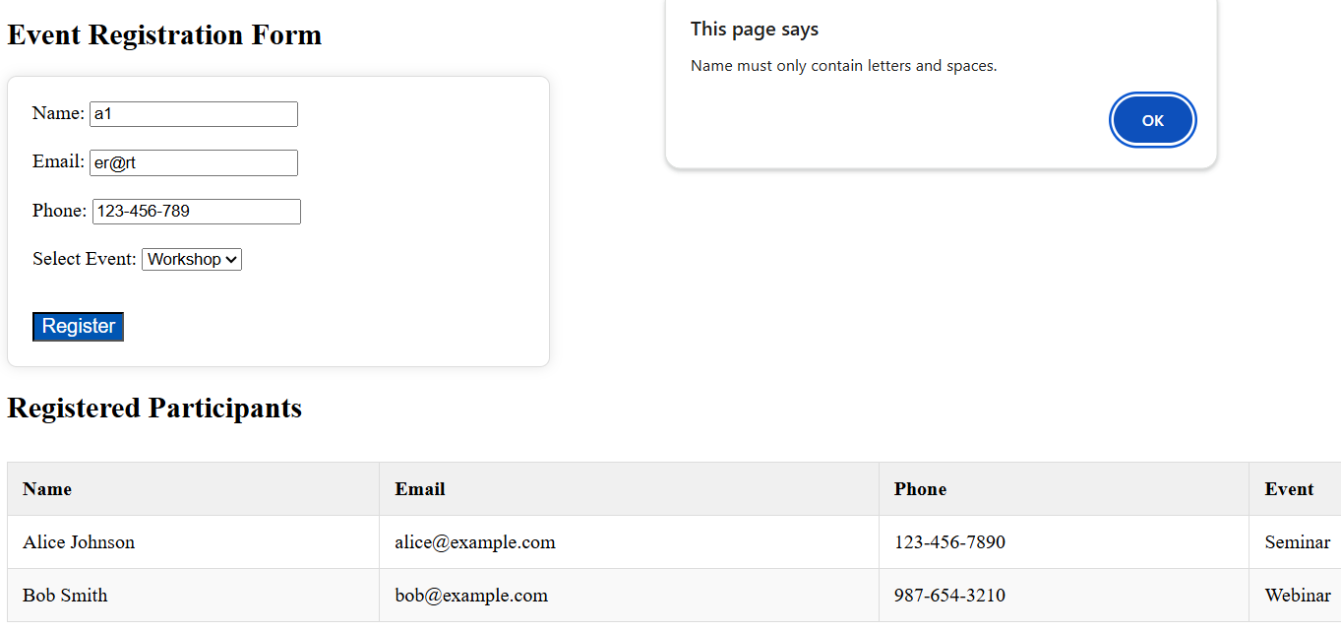

Figure 3

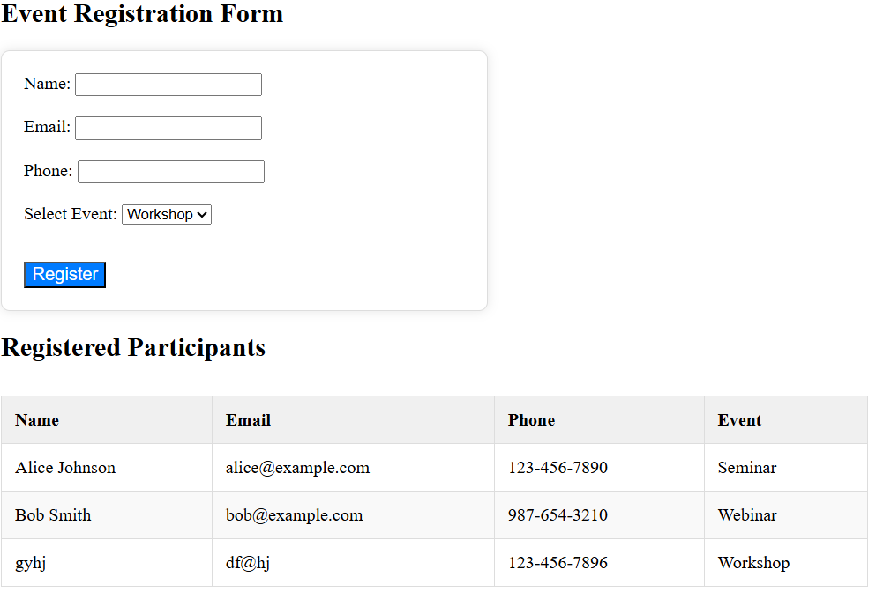

Figure 4

**Important notes:**

-You are supposed to write all the code **only in studentno_name.html** ex: 2001111_vesile.html. Please have your all code in one file. But do not just copy paste at the end. Your single file should run. Please check before submission.

- You are expected to obey the rules as mentioned above.

-Note that your program will go through plagiarism tool for coding.

**Submission:**

You are expected to submit **studentno_name.html** file by 20/5/2025 through the reserved place in Moodle

**Quiz and Grading**

Upon submitting your project, you are going to have a face to face quiz in the class on 22/5/25 in the lecture hour. The exact timing within the lecture hour will be announced a week before the quiz in the class. Quiz will test your knowledge on the project.

The grading will be done 40% for project and 60% for quiz. However your quiz results will effect your grade obtained from project submission. Such as a person who get 40/40 full point from project and 10/60 from quiz will get 8 points from the project + 10 point from the quiz so in total will get 18/100.

Total grade =Project grade *quiz coefficient + quiz grade

|  |  |
| --- | --- |
| Quiz Grade | Quiz Coefficient |
| 0-15 | 0.2 |
| 15-30 | 0.4 |
| 30-40 | 0.6 |
| 40-50 | 0.8 |
| 50-60 | 1 |

Not attending to the quiz and submitting the project will result you to get 8/100 the points in total even if you have a perfectly working project. Therefore, if you miss the quiz, you need to bring me a valid proof for a consideration(not in a wording). If you do not submit the project, you can still join to the quiz and try to get the point from the 40% of the grade.